MATLAB programs for chapter 6

Program 1: We cam write a MATLAB program to plot the poles and zeros of the transfer function with say T = 8; 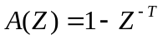

clear all;
B=[1 0 0 0 0 0 0 0 -1];
A=[1];
zplane(B,A);
figure;
freqz(B,A,1000);

The output of the program is a z plane plot (pole zero plot of the transfer function without feedback) shown in Figure 6.30. The frequency response plot will be as shown in Figure 6.31.
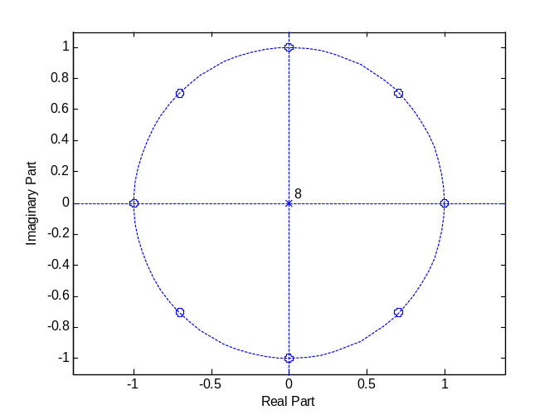
Figure 6.30 Pole zero plot of transfer function without feedback
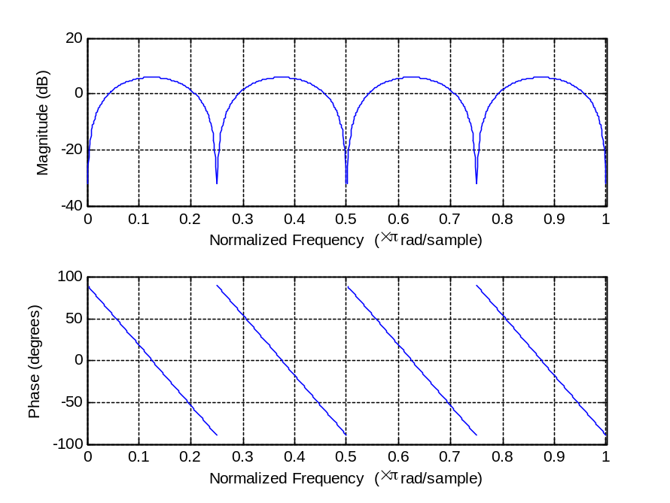
Figure 6.31 frequency response plot of a comb filter

Program 2: We cam write a MATLAB program to plot the poles and zeros of the transfer function with feedback with say T = 8 and b=0.8; 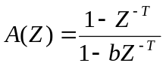

clear all;
B=[1 0 0 0 0 0 0 0 -1];
A=[1 0 0 0 0 0 0 0 -0.8];
zplane(B,A);
figure;
freqz(B,A,1000);

The output of the program is a z plane plot (pole zero plot of the transfer function with feedback) shown in Figure 6.33. We see that there are zeros plotted on the unit circle and poles very close to zeros with radius 0.8. The feedback causes the poles to move out from the origin and approach the zeros. When the poles are closer to zeros, partial cancellation of poles and zeros results about the unit circle. This happens in a small neighborhood about each zero. It causes the teeth of comb to become narrow with a relatively flat response between them. The frequency response plot will be as shown in Figure 6.34. We can see that the notches are made sharp by introducing feedback. Observe the change in the phase response.
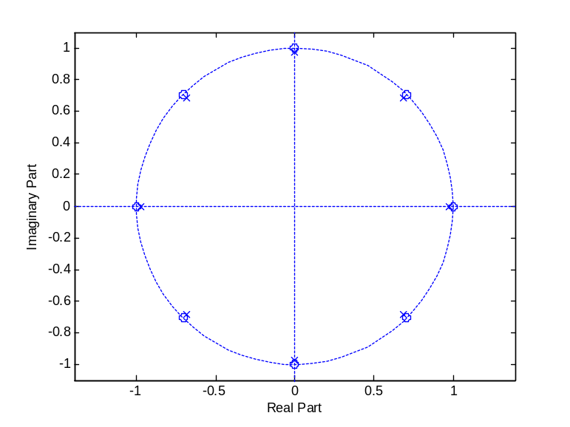
Figure 6.33 Pole zero plot of the transfer function with feedback.
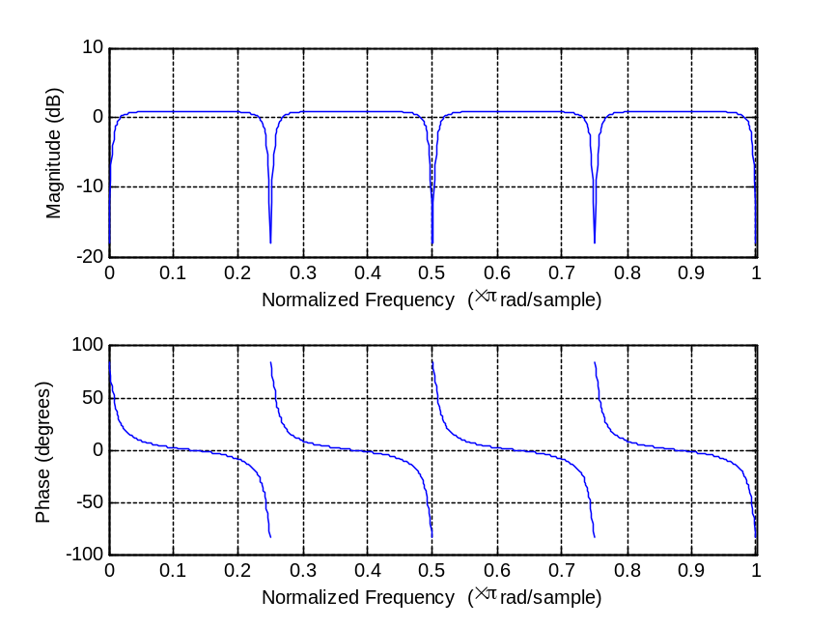
Figure 6.34 frequency response plot of a comb filter with feedback

Program:3:

